Charles J. Andrews
March 11, 1911 – April 28, 1985

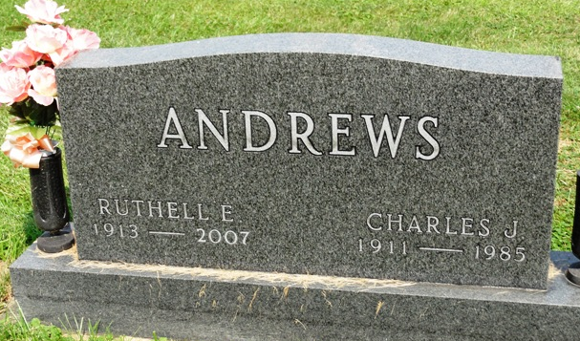
Photo by HoosierGirl88

Charles J. Andrews, 74, who had been ill since Nov. 4, 1984, due to cancer, died at 11 a.m. Sunday in Clinic Hospital, where he had been a patient the past two weeks. A member of the Ossian First Presbyterian Church, Mr. Andrews retired nine years ago after having operated the Ossian Public Service Station tank wagon for a period of 40 years.
Born March 11, 1911, in Adams County, he was a son of Forrest M. and Alice Rainier Andrews. His marriage was to Ruthell E. Woodward, who survives. Also surviving are a daughter, Mrs. Charles (Carolyn) Dennis of Cape Coral, Fla.; a son, Ross Andrews of Burnettsville; a sister, Mrs. Harvey (Veda) Haggard of Monroe, five grandchildren and four great-grandchildren.
Calling from 2 to 5 and 7 to 9 p.m. today is at the Elzey-Dickey-Haggard Funeral Home in Ossian. Services there at 2 p.m. Tuesday wil be in charge of Rev. Jay McMillen and burial will be in Oak Lawn Cemetery. Preferred are memorials to the Ossian First Presbyterian Church.

News Banner, Wells County, Indiana
Monday, April 29, 1985

