Harry Andes, Jr.
March 30, 1924 – May 16, 1999

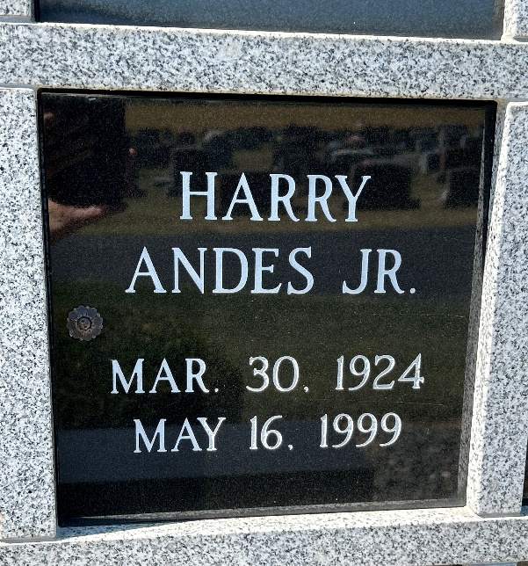
Photo by Barbara Baker Anderson

Indiana, U.S., Death Certificates, 1899-2017
Name Harry Andes Jr
Gender Male
Race Caucasian (White)
Marital Status Married
Age 75
Birth Date 30 Mar 1924
Birth Place Marna, Illinois
Death Date 16 May 1999
Death Place Fort Wayne, Allen, Indiana, USA
Death Registration Date 1999
Father Harry Andes, Sr.
Mother Gwendoline Hedger
Spouse Una Bernice (Lewis) Andes, informant
Burial 5/22/1999 Northern Indiana Crematory

