Bernice (Lewis) Andes
July 16, 1924 – November 22, 2021

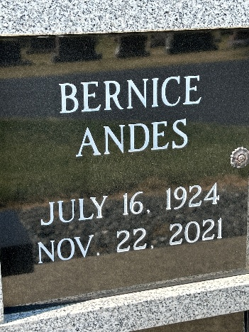
Photo by Barbara Baker Anderson

Bernice Andes, 97, formerly of Wells County, passed away on Monday, November 22, 2021 in Goshen. She was born July 16, 1924 in Champaign, Illinois, daughter of the late Tillman and Lillawah (Fugett) Lewis.
She worked for many years as a homemaker and devoted herself to caring for her family. In previous years, Bernice also enjoyed the time she spent caring for her community with her baked goods and candies. She was always appreciated by those who knew her for her thoughtfulness and kindness, as well as her generosity with her time. She was a long time, active member of Ossian United Methodist Church.
She is survived by her children, Michael Andes of Decatur, Gwen Mills of Goshen, Roger Andes of Los Angeles, CA, and Ronald Andes of Santa Fe, NM; brother, Forrest Lewis of Syracuse, IN; seven grandchildren and two great grandchildren.
In addition to her parents, she was preceded in death by her husband, Harry Andes, Jr. in 1999; sister, Wilma Lewis and brother, Rexford Lewis.
Graveside services will be held at a later date. Contributions in Bernice's memory may be made to Ossian United Methodist Church, 201 West Mill Street, Ossian, Indiana 46777.

Elzey-Patterson-Rodak Funeral Home, Wells County, Indiana

