Terry Joe Anderson
July 17, 1954 – November 19, 1991

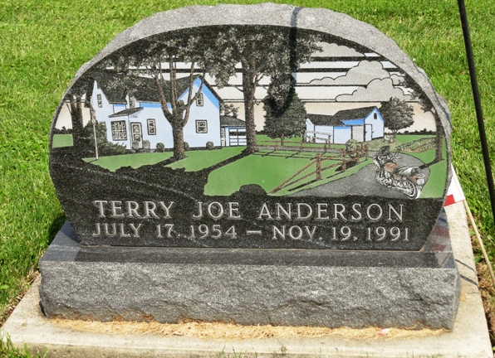
Photo by HoosierGirl88

Indiana, U.S., Death Certificates, 1899-2017
Name Terry Joe Anderson
Gender Male
Race White
Marital Status Married
Age 37
Birth Date 17 Jul 1954
Birth Place Lampass, Texas
Death Date 19 Nov 1991
Death Place Fort Wayne, Allen, Indiana, USA
Cause of Death Cardiac arrest caused by electrical shock
Death Registration Date 1991
Father Thomas Morehouse
Mother Ann Elliott
Spouse Kimberly (Hamilton) Anderson, informant
Burial 11/22/1991 Oaklawn Cemetery

