Omer Leroy Amburn
October 28, 1906 – January 9, 1999

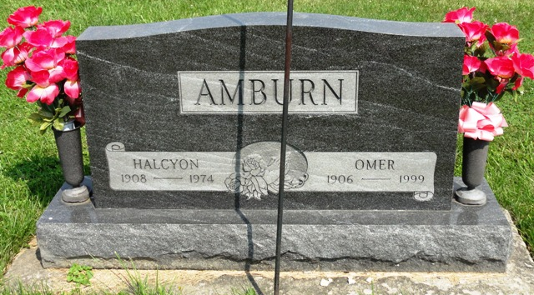
Photo by HoosierGirl88

Indiana, U.S., Death Certificates, 1899-2017
Name Omer Leroy Amburn
Gender Male
Race Caucasian (White)
Marital Status Married
Age 92
Birth Date 28 Oct 1906
Birth Place Randolpn County
Death Date 6 Jan 1999
Death Place Fort Wayne, Allen, Indiana, USA
Death Registration Date 1999
Father Ollie Amburn
Mother Carrie McGunicle
Spouse Lucille Mary (Bauer) Amburn, informant
Burial 1/9/1999 Oak Lawn Cemetery

