Lenna Halycon (Woodring) Amburn
June 1, 1908 – October 31, 1974

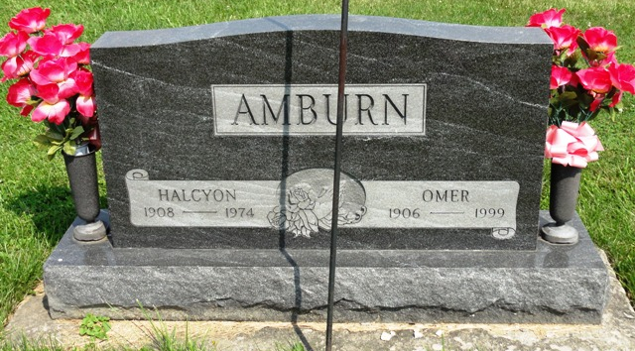
Photo by HoosierGirl88

Indiana, U.S., Death Certificates, 1899-2017
Name Lenna Halcyon Amburn
[Lenna Halcyon Woodring]
Gender Female
Race White
Marital Status Married
Age 66
Birth Date 1 Jun 1908
Birth Place Indiana
Death Date 31 Oct 1974
Death Place Fort Wayne, Allen, Indiana, USA
Death Registration Date 1974
Father Floy Woodring
Mother Calie Thomas
Spouse Omer Amburn, informant
Burial Oak Lawn 11-4-1974

