E. Maureen (Bushee) Amburn
November 5, 1931 – May 22, 2008

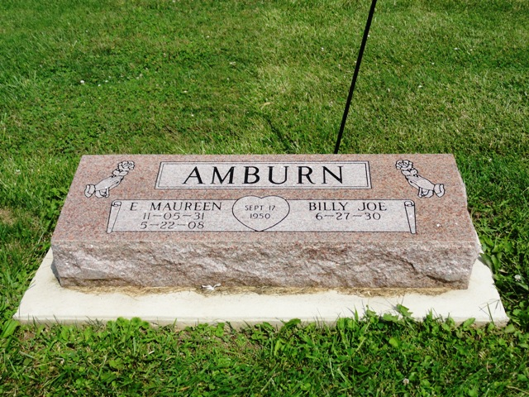
Photo by HoosierGirl88

E. Maureen Amburn, 76, of Ossian, died today, May 22, 2008, at Bluffton Regional Medical Center. Born in Wells County on Nov. 5, 1931 to Daniel and Vera (Richey) Bushee, she married Billy Joe Amburn; he survives.
Mrs. Amburn was a homemaker, and a member of Ossian United Methodist Church.
Other surviving relatives include one daughter, Jan M. (Larry) Stronczek of Ossian; one son, Joe A. (Emelie) Amburn of San Diego, Calif.; and three grandchildren. Mrs. Amburn was preceded in death by a brother.
Funeral services will be at 2 p.m. Saturday, at the Elzey-Patterson-Rodak Funeral Home in Ossian. Calling hours will be from 12 to 2 p.m. Saturday at the funeral home. Burial is at Oak Lawn Cemetery.
Preferred memorials are to the church or Bluffton Home Health Care.

Bluffton News-Banner, Wells County, Indiana
Thursday, May 22, 2008

