Evangeline E. (Warpup) Alspach-Sheley
August 25, 1922 – February 16, 1984

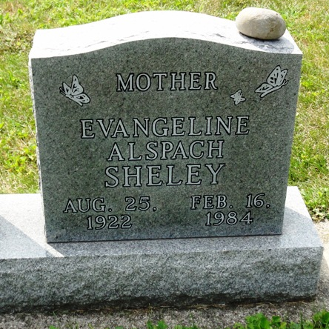
Photo by HoosierGirl88

Indiana, U.S., Death Certificates, 1899-2017
Name Evangeline Emma Alspach
[Evangeline Emma Warpup]
Gender Female
Race White
Marital Status Married
Age 61
Birth Date 25 Aug 1922
Birth Place Indiana
Death Date 16 Feb 1984
Death Place Yoder, Allen, Indiana, USA
Death Registration Date 1984
Father Harmon Warpup
Mother Flora Gephart
Spouse Robert A. Alspach, husband
Burial Oak Lawn Cemetery, 2/18/1984
**
Evangeline Emma WARPUP from tree Whitestine/Lahr & Young/Titus
Birth 25 Aug 1922 Huntington, Indiana, USA
Residence 1950 Wells, Indiana, USA
Marriage 30 Dec 1968 Markle, Huntington, Indiana, USA
Death 16 Feb 1984 Yoder, Allen, Indiana, USA
Father Harmon F. WARPUP (1870-1932)
Mother Flora Katherine GEPHART (1894-1970)
Spouse Robert Allen ALSPACH (1920-1998)
35705 People 9 Records 9 Sources

