William Ray Allen
March 8, 1885 – April 7, 1955

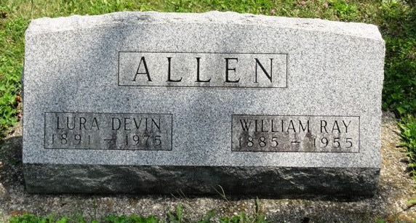
Photo by HoosierGirl88

Dr. William Ray Allen was a University of Kentucky zoologist who extensively studied Orinoco and Amazon river basin wildlife. As a fellow at the University of Illinois, he accompanied Dr. Carl H. Eigenmann to Peru in 1918 to study fish. He spent six months surveying fresh-water fish fauna in Lake Titicaca in 1920.
Co-authored "Fishes of Western South America I. The Intercordilleran and Amazonian Lowlands of Peru & II. The High Pampas of Peru, Bolivia, and Northern Chile with a revision of the Peruvian Gymnotidae and the Genus Orestias" published in 1942.
A man of great academic achievement, he was foremost a family man, a loving husband and proud father of three daughters.

Unknown source
**

Kentucky, U.S., Death Records, 1852-1965
Name Dr William Ray Allen
Gender Male
Death Age 70
Birth Date 8 Mar 1885
Birth Place Wells C, Indiana
Death Date 7 Apr 1955
Death Place Lexington, Fayette, Kentucky, USA
Father Elza Allen
Mother Ellen Chupp
Informant Mrs Lura D Allen
Burial 4/10/1955 Ossian Cemetery

