Wealthy Adell Allen
January 22, 1871 – April 29, 1960

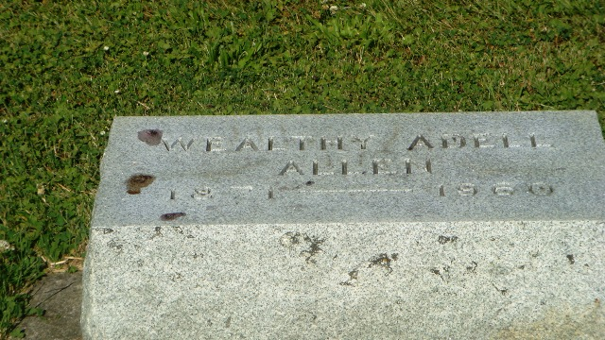
Photo by HoosierGirl88

Wealthy (Adell) L. Allen from tree Carr Family Tree
Birth 22 Jan 1871 Wells, Indiana, USA
Residence 1930 Ossian, Wells, Indiana, USA
Death 29 Apr 1960 Wells, Indiana, USA
Father Ransom Allen (1842-1919)
Mother Elizabeth Ellen Todd (1847-1921)
10874 People 6 Records 10 Sources

