Thomas Lee Allen
November 20, 1942 – September 6, 2018

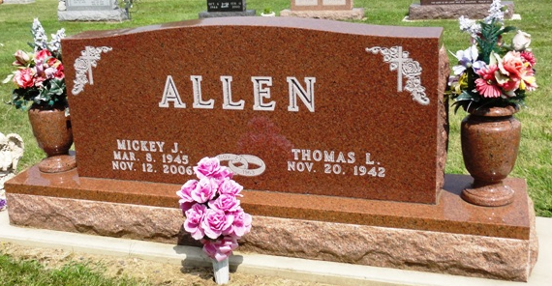
Photo by HoosierGirl88

THOMAS L. ALLEN, 75, of Ossian, passed away on Thursday, Sept. 6, 2018. Born Nov. 20, 1942, he was a son of the late Russell and Martha (Edris) Allen. He was the owner and operator of ATCO Inc.
Surviving family include his daughters, Sherri Allen and Angela (Tony) Chaney; and son, Michael Allen. He was also preceded in passing by his wife of 43 years, Mickey (Hower) Allen.
Funeral service is 3 p.m. Monday, Sept. 10, 2018, at Elzey-Patterson-Rodak Funeral Home, 120 West Mill St., Ossian, with visitation one hour prior. Visitation also from 1 to 4 and 6 to 8 p.m. Sunday, Sept. 9, 2018, at the funeral home. Burial will be in Oak Lawn Cemetery, Ossian.
Memorials may be made to Northern Wells Food Pantry, Ossian.

Fort Wayne Newspapers, Allen County, Indiana
September 8, 2018

