Stanley H. Allen
October 25, 1877 – July 14, 1942

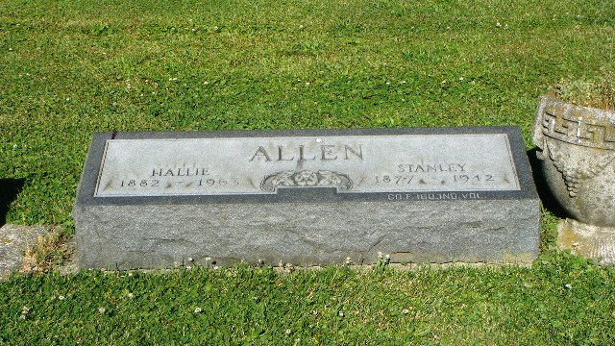
Photo by Kay Bradtmiller

Stanley Allen
in the Indiana, U.S., Death Certificates, 1899-2017

Name Stanley Allen
Gender Male
Race White
Age 64
Marital Status Married
Birth Date 25 Oct 1877
Birth Place Jefferson Twp Wells County
Death Date 14 Jul 1942
Death Place Rural, Wells, Indiana, USA
Death Registration Date 1942
Father Ransom Allen
Mother Elizabeth Todd
Spouse Hallie; age 63
Informant: Mrs. Hallie Allen; Ossian, Indiana
Burial: July 16, 1942; Oaklawn Cemetery; Ossian, Indiana

