Sarah Ann Allen
January 1, 1871 – September 1, 1936

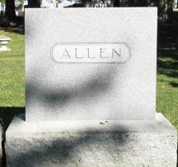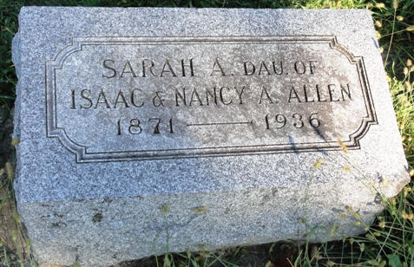
Photo by HoosierGirl88

Indiana, U.S., Death Certificates, 1899-2017
Name Miss Sarah Ann Allen
Gender Female
Race White
Marital Status Single
Age 65yr 9m 0d
Birth Date 1 Jan 1871
Birth Place Wells County, Indiana
Death Date 1 Sep 1936
Death Place Jefferson, Wells, Indiana, USA
Death Registration Date 1936
Father Isaac Allen
Mother Nancy Ann Wilson
Informant C. W. Allen, Ossian, IN
Burial Ossian, Indiana 9/3/1936

