Ransom Allen
March 15, 1842 – February 14, 1919

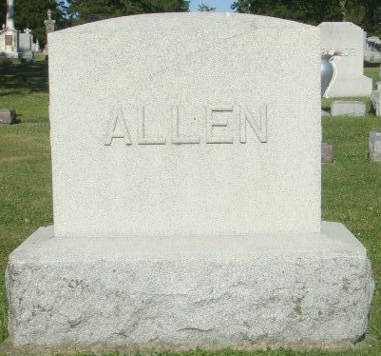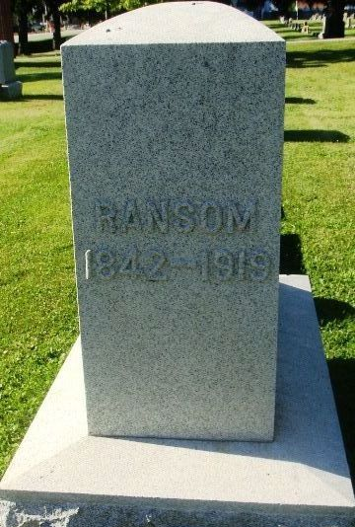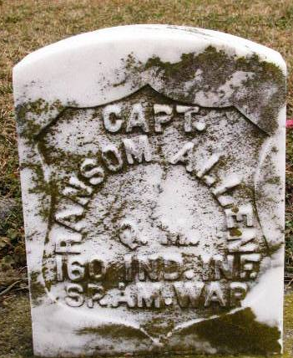
Photo by Kay Bradtmiller

Indiana, U.S., Death Certificates, 1899-2017
Name Ransom Allen
Gender Male
Race White
Marital Status Married
Age 76y 10m 29d
Birth Date 15 Mar 1842
Birth Place Ohio
Death Date 14 Feb 1919
Death Place Wells, Indiana, USA
Death Registration Date 1919
Father Hezakiah Allen
Mother Sarah Rinear
Spouse Elizabeth Allen, informant
Burial Ossian, Ind. 2/17/1919
**

VETERAN SERVED THE COLORS IN TWO WARS

Veterans will recognize in the picture the face of a comrade who served the colors, and was ready to go again to fight for freedom had not age prevented his acceptance.
Ransom Allen, who died last fall and was buried with military honors at Ossian, first answered the call of his country by enlisting in Company A of the old Thirtieth Indiana volunteer infantry under Col. Sion S. Bass, in 1861, and served four years, taking part in many of the great battles of the war, among them Shiloh, Stone River, Chickamauga, and the advance on Atlanta.
When the Spanish-American war broke out, he was again ready to defend the flag and went out as regimental commissary of the old 160th Indiana infantry, which went to Cuba. The veteran was a member of Lawton-Wayne post, G.A.R., and Henry W. Lawton camp No. 35, United Spanish War Veterans.

Fort Wayne Journal-Gazette, Allen County, Indiana
May 11, 1919, p. 10B

