Nancy A. (Wilson) Allen
October 31, 1848 – November 29, 1931

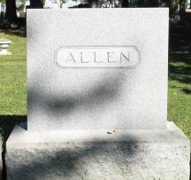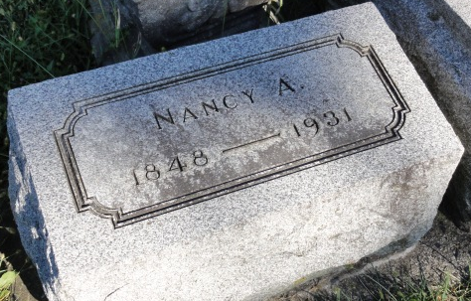
Photo by HoosierGirl88

Indiana, U.S., Death Certificates, 1899-2017
Name Nancy Ann Allen
[Nancy Ann Wilson]
Gender Female
Race White
Marital Status Widow
Age 83y 0m 30d
Birth Date 31 Oct 1848
Birth Place Ohio
Death Date 29 Nov 1931
Death Place Jefferson, Wells, Indiana, USA
Death Registration Date 1931
Father Gibson Wilson
Mother Nancy Ann Harris
Spouse Isaac Allen
Burial Ossian, Ind 11/30/1931
**

Indiana, U.S., Marriage Certificates, 1960-2012
Name Isaac Allen
Gender Male
Marriage License Date 18 Nov 1868
Marriage Date 19 Nov 1868
Marriage Place Wells, Indiana, USA
Spouse Nancy Ann Wilson
Officiator W M Donaldson

