Mickey Jean (Hower) Allen
March 8, 1945 – November 12, 2006

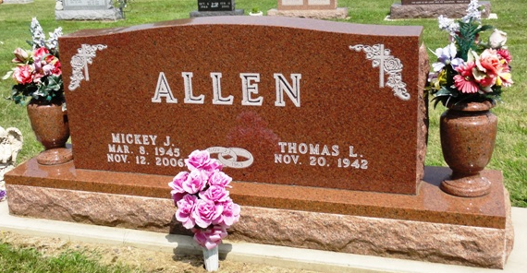
Photo by HoosierGirl88

MICKEY J. ALLEN, 61, of Ossian, died Sunday, Nov. 12, 2006, at Lutheran Hospital, Fort Wayne. Born March 8, 1945, in Wells County, she was a self employed hairdresser in her home for 41 years. She was a member of Ossian First Presbyterian Church and Indiana Hairdresser's Association.
Mickey loved her grandchildren, lake activities and Florida vacations. She married Thomas L. Allen of Ossian on Nov. 23, 1963 at Ossian First Presbyterian Church.
Surviving are her husband of 43 years, Thomas; mother, Helen D. Hower of River Terrace Estates, Bluffton; daughters, Sherri L. (Craig) Stoller of Warsaw and Angela J. (Tony) Chaney of Bluffton; son, Michael T. (Amanda) Allen of Ossian; sister, Sally Miller of Morgantown, Ky.; and 12 grandchildren.
Funeral service is 11 a.m. Thursday at Ossian First Presbyterian Church, with calling one hour prior to service. Calling also from 1 to 8 p.m. Wednesday at Elzey-Patterson-Rodak Funeral Home, Ossian Chapel. Burial in Oak Lawn Cemetery, Ossian.
Memorials to Norwell High School Band, Norwell High School Athletic Department or Ossian First Presbyterian Church.

Fort Wayne Newspapers, Allen County, Indiana
November 14, 2006

