Maude Z. (Vinecore) Allen
December 3, 1872 – May 3, 1953

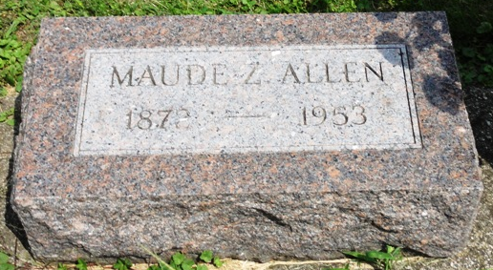
Photo by HoosierGirl88

Indiana, U.S., Death Certificates, 1899-2017
Name Lafayette L Allen
Gender Male
Race White
Marital Status Married
Military Spanish American
Age 79
Birth Date 20 May 1871
Birth Place Ossian
Death Date 9 Oct 1950
Death Place Ossian, Wells, Indiana, USA
Death Registration Date 1950
Father Matthew R Allen
Mother Mary J Hoopengardner
Informant Alta M. Frye, Ossian
Burial 10/12/1950 Oak Lawn

