Mattie E. Allen
1862 - 1899

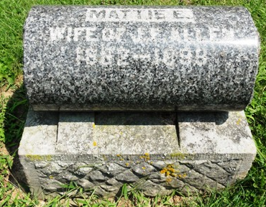
Photo by HoosierGirl88

Michigan, U.S., Marriage Records, 1867-1952
Name Mattie E Clark
Gender Female
Race White
Age 23
Birth Date abt 1863
Birth Place Ossion, Indiana
Marriage Date 26 Nov 1886
Marriage Place Reading, Hillsdale, Michigan, USA
Residence Place Ossion, Indiana
Spouse Elmer E Allen
Record Number 1289
**
Martha Clark from tree Clark Family Tree
Birth 1862 Ossian, Wells, Indiana, USA
Residence 1870 Johnson, Missouri, USA
Marriage 26 Nov 1886 Reading, Hillsdale, Michigan, USA
Death 1899
Father Jeremiah Clark (1820-1900)
Mother Catharine Porter (1823-1897)
Spouse Joseph Elmer Allen (1861-1932)
4183 People 3 Records 3 Sources

