Lura B. (Devin) Allen
September 16, 1891 – August 21, 1975

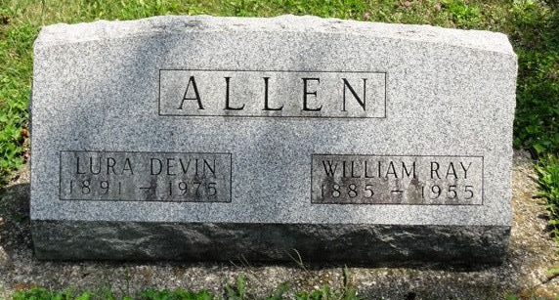
Photo by HoosierGirl88

Lura Belle Devin from tree Premo Family Tree
Birth 16 Sep 1881 Wabash, Clark, Illinois, USA
Residence 1910 Gibson, Indiana, USA
Death 21 Aug 1975 Lexington, Fayette, Kentucky, USA
Father John Peyton Devin (1848-1925)
Mother Clara Estimate Higgins (1851-1938)
7717 People 3 Records 9 Sources

Note difference in birth years on stone (1891) and in record (1881)

