Lulu Jane Allen
May 3, 1868 – August 4, 1952

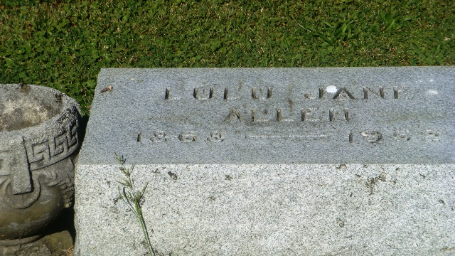
Photo by HoosierGirl88

Indiana, U.S., Death Certificates, 1899-2017
Name Lulu Jane Allen
Gender Female
Race White
Marital Status Never Married (Single)
Age 84
Birth Date 3 May 1868
Birth Place Near Ossian
Death Date 4 Aug 1952
Death Place Ossian, Wells, Indiana, USA
Death Registration Date 1952
Father Ranson Allen
Mother Elizabeth Todd
Informant Weltha Adell Allen, Ossian, Ind.
Burial 8/6/1952 Oak Lawn

