Lucinda Ellen (Chupp) Allen
August 31, 1862 – February 1, 1899

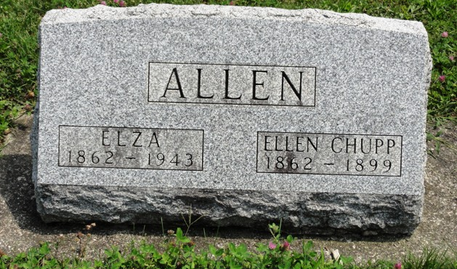
Photo by HoosierGirl88

Lucinda Ellen Chupp from tree Edwards/Webb/Lakeman/Pedersen Family Tree (UPDATED)
Birth 31 Aug 1862 Ossian, Wells, Indiana, USA
Residence 1880 Wells, Indiana, USA
Marriage 10 May 1884 Ossian, Wells, Indiana, USA
Death 1 Feb 1899 Ossian, Wells, Indiana, USA
Father Gideon Gordon Chupp (1825-1899)
Mother Elizabeth Frederick (1829-1915)
Spouse Elza A. Allen (1862-1943)
4379 People 11 Records 14 Sources

