Isaac Allen
July 15, 1844 – September 12, 1926

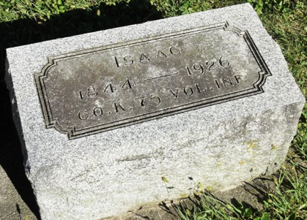
Photo by HoosierGirl88

Indiana, U.S., Death Certificates, 1899-2017
Name Isaac Allen
Gender Male
Race White
Marital Status Married
Age 82y 1m 27d
Birth Date 15 Jul 1844
Birth Place Ohio
Death Date 12 Sep 1926
Death Place Jefferson, Wells, Indiana, USA
Death Registration Date 1926-1927
Father Hezeziah Allen
Mother Sarah Rinear
Spouse Nancy Allen
Informant Sadie Allen
Burial Ossian, Ind. 9/14/1926
**

Indiana, U.S., Marriage Certificates, 1960-2012
Name Isaac Allen
Gender Male
Marriage License Date 18 Nov 1868
Marriage Date 19 Nov 1868
Marriage Place Wells, Indiana, USA
Spouse Nancy Ann Wilson
Officiator W M Donaldson

