Hallie Albertine (Ormsby) Allen
January 24, 1882 – February 11, 1963

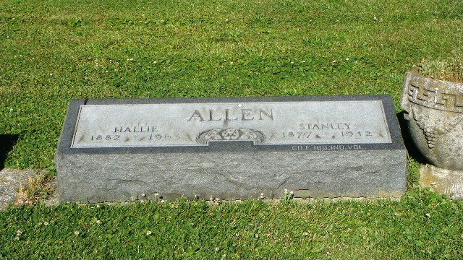
Photo by Kay Bradtmiller

Hallie Albertine Allen
in the U.S., Social Security Applications and Claims Index, 1936-2007

Name Hallie Albertine Allen
[Hallie Albertine Ormsby]
Gender Female
Race White
Birth Date 24 Jan 1882
Birth Place Union Twp We, Indiana
Father Lee Ormsby
Mother Lucy A Brickley
SSN xxx
Notes Aug 1952: Name listed as HALLIE ALBERTINE ALLEN
**

Ohio, U.S., Death Records, 1908-1932, 1938-2022

Name Hallie A Allen
Gender Female
Race White
Marital Status Widowed
Age 81
Birth Date Abt 1882
Residence Place Cleveland, Cuyahoga, Ohio, USA
Death Date 11 Feb 1963
Death Place East Cleveland, Cuyahoga, USA
Certificate Number 10029
Inquest Questions Certifier: Physician; Autopsy Performed?: Yes, Used For Certification

