Elza A. Allen
March 15, 1862 – October 10, 1943

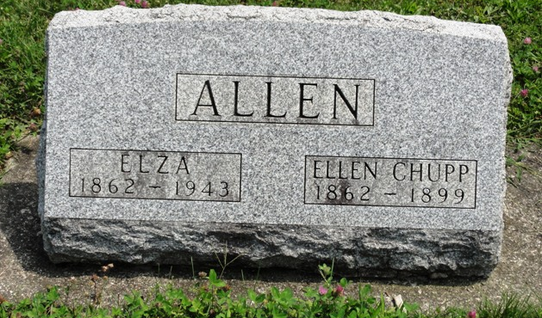
Photo by HoosierGirl88

Originally named Jacob A. Lepper as he appeared in the 1870 census, he was the son of Martha M. Allen and Jacob H. Lepper. He was conceived shortly before his father enlisted as a Union soldier on 20 Aug 1861. The couple was unmarried and Jacob did not return from the war.
Elza's father, Jacob H. Lepper, served in Co A, 30 Reg't Indiana Infantry where he was taken prisoner at Chickamauga on 13 Sep 1863 and died a prisoner of war at Florence, South Carolina, on 1 Nov 1864. Jacob's name has been added to his father's tombstone (John A. Lepper) at Prospect Cemetery, Uniondale, Wells County, Indiana.
In 1870 and 1880, Elza lived with his mother and grandmother Rebecca Rachel Allen in Wells County, Indiana. His mother Martha M. Allen married William Albert Ober on 30 Dec 1880 and moved from Wells to Starke County, Indiana, where she is presumably buried.
Elza is listed as Elza Allen in the 1880 census and used that name until his death. He married Lucinda Ellen Chupp on 10 May 1884 in Ossian, Wells County, Indiana. They had six children before she died of tuberculosis at the very early age of 36. On 11 Aug 1901, he married Elnora Bell Ault, a young divorcee with 2 young children. He and Elnora had three children before they divorced in 1915. Elza did not marry again.

Unknown source

