Elisabeth E. (Todd) Allen
December 22, 1847 – January 31, 1921

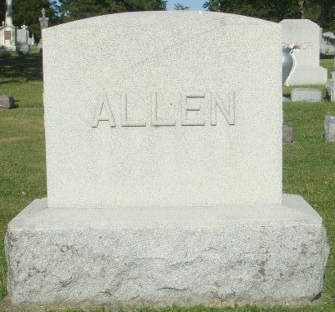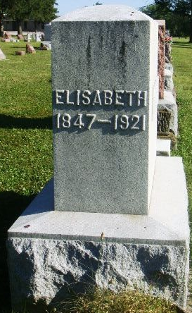
Photo by Kay Bradtmiller

Indiana, U.S., Death Certificates, 1899-2017
Name Elizabeth E. Allen
[Elizabeth E. Toad]
Gender Female
Race White
Marital Status Widow
Age 73y 1m 7d
Birth Date 22 Dec 1847
Birth Place Pennsylvania
Death Date 31 Jan 1921
Death Place Ossian, Wells, Indiana, USA
Death Registration Date 1921
Father Jacob Todd
Mother Jane Thomas
Spouse Ransom Allen
Informant Stanley Allen
Burial Ossian, IN 2/3/1921Hallie Albertine Allen

