Cyrus Wilson Allen
October 3, 1872 – July 21, 1957

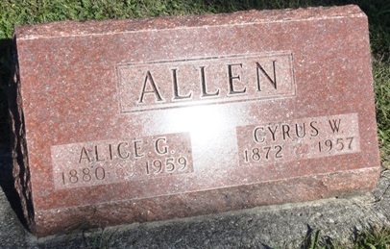
Photo by Kay Bradtmiller

Indiana, U.S., Death Certificates, 1899-2017
Name Cyrus Wilson Allen
Gender Male
Race White
Marital Status Married
Age 84
Birth Date 3 Oct 1872
Birth Place Indiana
Death Date 21 Jul 1957
Death Place Bluffton, Wells, Indiana, USA
Death Registration Date 1957
Father Isaac Allen
Mother Nancy Wilson
Informant Mrs. Alice Allen, wife
Burial 7/23/1957 Oak Lawn Cemetery

