Bonnie L. (Follis) Allen
June 9, 1936 – May 26, 1986

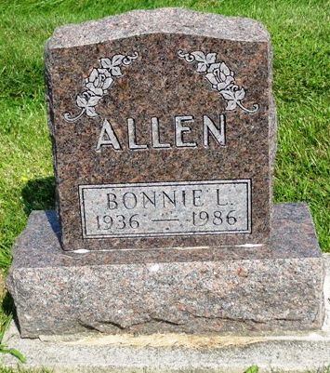
Photo by Kay Bradtmiller

Indiana, U.S., Death Certificates, 1899-2017
Name Bonnie L Allen
Gender Female
Race White
Marital Status Divorced
Age 49
Birth Date 9 Jun 1936
Birth Place Indiana
Death Date 26 May 1986
Death Place Bluffton, Wells, Indiana, USA
Death Registration Date 1986
Father Alvin Follis
Mother Lola Brown
Informant Linda Lara, daughter
Burial Oak Lawn 5/29/1986
**
Bonnie Lou Follis from tree Follis, Fallis, Brunson, DeShazo in America
Birth 9 Jun 1936 Bluffton, Wells, Indiana, USA
Marriage 12 Jan 1959
Residence 1986 Bluffton, Wells, Indiana, USA
Death 26 May 1986 Bluffton, Wells, Indiana, USA
Father Alvin Gerald Follis (1910-1991)
Mother Lola Elizabeth Brown (1913-2004)
Spouse Eddie Allen, Jr.
29607 People 12 Records 22 Sources

