Alice (Glass) Allen
January 8, 1880 – April 6, 1959

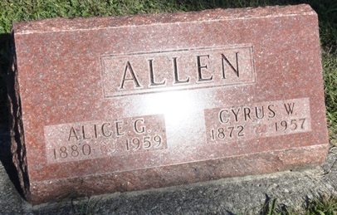
Photo by Kay Bradtmiller

Alice Allen
in the Indiana, Death Certificates, 1899-2011
Name: Alice Allen
[Alice Glass]
Gender: Female
Race: White
Age: 79
Marital Status: Widowed
Birth Date: 8 Jan 1880
Birth Place: Indiana
Death Date: 6 Apr 1959
Death Place: Bluffton, Wells, Indiana, USA
Father: Andrew J. Glass
Mother: Emily McCorkle
Informant: Mrs. Leon Duncan; very good friend; Sherwood, MI
Burial: April 9, 1959; Oak Lawn Cem., Ossian, Ind.

