Vernelle M. Alexander
May 1, 1905 – June 25, 1984

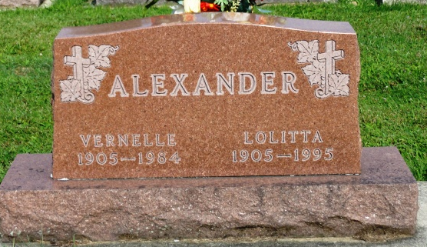
Photo by Kay Bradtmiller

Vernelle M. Alexander
in the Indiana, Death Certificates, 1899-2011
Name: Vernelle M. Alexander
Gender: Male
Race: White
Age: 79
Marital Status: Married
Birth Date: 1 May 1905
Birth Place: Illinois
Death Date: 25 Jun 1984
Death Place: Fort Wayne, Allen, Indiana, USA
Father: Joseph Alexander
Mother: Dessie Marvin
Spouse: Lolitta Haiflich
Informant: Lolitta Alexander; wife; Ossian, Ind.
Burial: June 28, 1984; Oak Lawn Cem., Ossian, Ind.

