Serena M. (McFarren) Alexander
March 2, 1907 – November 25, 1978

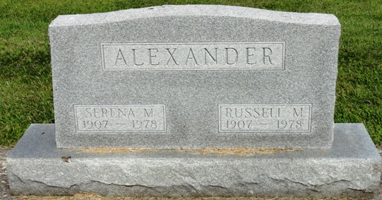
Photo by Kay Bradtmiller

Indiana, U.S., Death Certificates, 1899-2017
Name Serena M Alexander
[Serena M McFarren]
Gender Female
Race White
Marital Status Married
Age 70
Birth Date 2 Nov 1907
Birth Place Indiana
Death Date 27 Sep 1978
Death Place Fort Wayne, Allen, Indiana, USA
Death Registration Date 1978
Father William Leslie McFarren
Mother Della D Robbins
Spouse Russell Alexander, informant
Burial Oak Lawn Cemetery 9/29/1978

