Lolitta I. (Haiflich) Alexander
December 13, 1905 -1995

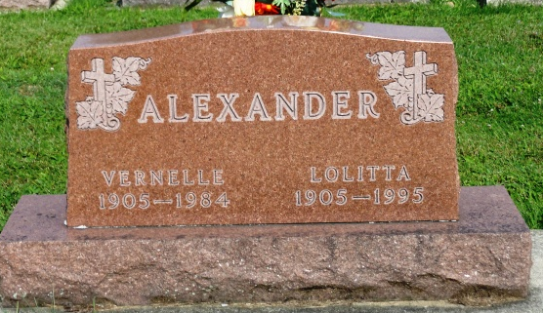
Photo by Kay Bradtmiller

Lolitta Alexander, 89

Mrs. Lolitta I. Alexander, 89, died at 9:50 pm Saturday at Christian Care Retirement Community.
Born December 13, 1905 in Uniondale, she was the daughter of Harley and Lulu Nicholson Haiflich. Her marriage March 24, 1940 in Uniondale was to Vernelle M. Alexander, who died June 25, 1984.
Mrs. Alexander was a member of the Ossian United Methodist Church and Jefferson Extension Club.
Surviving are a sister, Nellie M. Harris of Bluffton; a brother, Lloyd Hershel Haiflich of Bluffton and several nieces and nephews.
Rites will be officiated by Dr. Robert Priest and Rev. Kenneth Fahl at 10:30 am Wednesday at Elzey & Haggard Funeral Home, Ossian, where friends may call from 2 to 5 and 7 to 9 pm Tuesday.
Burial will be in Oak Lawn Cemetery. Memorials to Ossian United Methodist Church or Christian Care Retirement Center.

Berne Library Heritage Room
Misc. Death Book BB, Image# 7

