Truman Dell Alberson
May 8, 1940 - 1962

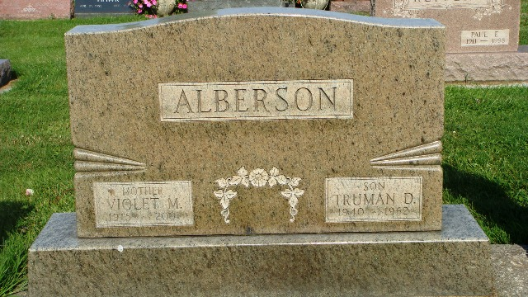
Photo by Kay Bradtmiller

Indiana, U.S., Birth Certificates, 1907-1944
Name Truman Dell Alberson
Gender Male
Birth Date 8 May 1940
Birth Place Gary, Lake, Indiana, USA
Father Andrey Carter Alberson, age 28
Mother Violet Maxine Shady, age 25 3 of 3 children living
Certificate Number 21331
Roll number 40474_357730
Volume Range 41 - 45

