Mary Virginia ‘Jenny’ (Reasor) Akin
October 27, 1935 – July 9, 2024

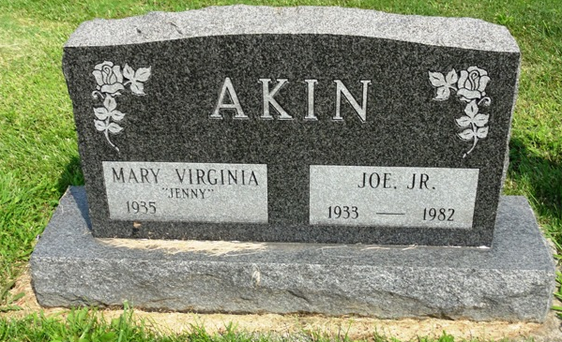
Photo by HoosierGirl88

Mary Virginia "Jenny" (Reasor) Akin, 88 was called home to the house of the Lord on Tuesday, July 9, 2024 in Fort Wayne. Jenny was born in Crawford County, Indiana on October 27, 1935, daughter of the late Melvin and Marie (Schlensker) Reasor and wife of the late Joe Akin Jr. Jenny was a resident of Ossian for 50 years and a member of First United Methodist Church.
During her life she worked for Ajax, Bowmar, Caylor Nickel Hospital and retired from The State Developmental Center in 2000. Jenny loved to dance and could be very stubborn. She was always there for her grandchildren's school events, sporting events and religious milestones. She was willing to go on field trips and up for taking the road trips to visit great grandma. Her grandchildren loved going and spending the night, getting Happy Meals, having pizza fixed in the toaster oven, diet coke and ice cream.
Jenny was always cold, especially her fingers and sometimes wore gloves to keep them warm. All of her family remember how her eyes and face would light up with a big smile when they came into the room. No matter how old they were, they were always her baby. Her Great-grand kids loved her “Grandma hugs!” People watching, coloring together, magic cookies that appeared from nowhere, chocolate pudding, watching Wheel of Fortune and Jeopardy and the way she would sandbagging when they played Rummy. But the most important memory was she was always there! To talk to, supporting us, watching out for us and caring for us, ALWAYS! She was a sweet quiet woman and will be missed so much!
Jenny is survived by her children, Dianna (Courtney) Watt, of Mesa, AZ, Michael (Theresa) Akin, of Corpus Christi, TX and Pamela (Peter) Fink, of Fort Wayne, IN; three grandchildren; three step grandchild-ren; eight great-grandchildren; seven step great-grandchildren; sisters, Bernita Stillman of Floyds Knobs, IN and Barbara Blakley of Clarks-ville, IN; brother, Gary Reasor of Shepherdsville, KY; and numerous nieces and nephews.
A funeral service will be held at 1:00 pm on Thursday, July 18, 2024 at Elzey-Patterson-Rodak Funeral Home, 120 West Mill Street, Ossian, Indiana 46777 with visitation beginning at 10:00 am. Burial to follow the service at Oak Lawn Cemetery. Memorial contributions may be made to the Dementia Society.

Elzey-Patterson-Rodak Funeral Home, Wells County, Indiana

