Joe Akin Jr.
September 15, 1933 – December 22, 1982

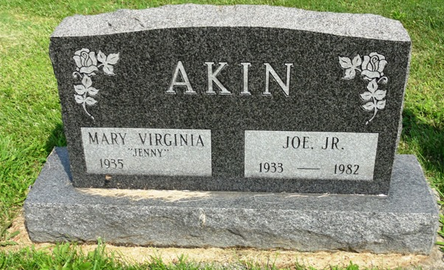
Photo by HoosierGirl88

Joe Akin Jr
in the Indiana, Death Certificates, 1899-2011
Name: Joe Akin Jr
Gender: Male
Race: White
Age: 49
Marital Status: Married
Birth Date: 15 Sep 1933
Birth Place: KY.
Death Date: 22 Dec 1982
Death Place: Bluffton, Wells, Indiana, USA
Father: Joseph Akin
Mother: Cecil Harvey
Spouse: Mary Reasor
Informant: Mary Reasor; Ossian, Ind.
Burial: Dec. 24, 1982; Oak Lawn Cem., Ossian, Ind.

