James Elbert Agans
August 20, 1919 – June 29, 1929

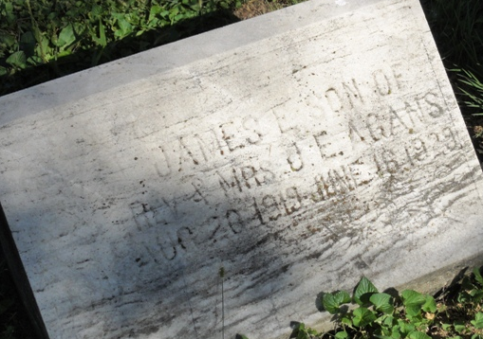
Photo by HoosierGirl88

Indiana, U.S., Death Certificates, 1899-2017
Name James Elbert Agans
Gender Male
Race White
Marital Status Single
Age 9y 9m 26d
Birth Date 20 Aug 1919
Birth Place Burgess Illinois
Death Date 16 Jun 1929
Death Place Jefferson, Wells, Indiana, USA
Cause of death Automobile accident
Death Registration Date 1929
Father Jesse E. Agans, informant
Mother Estella M. Rang
Burial Ossian, Ind. 6/18/1929

