Norma Lucille (Morris) Adkins
July 10, 1910 – February 8, 1992

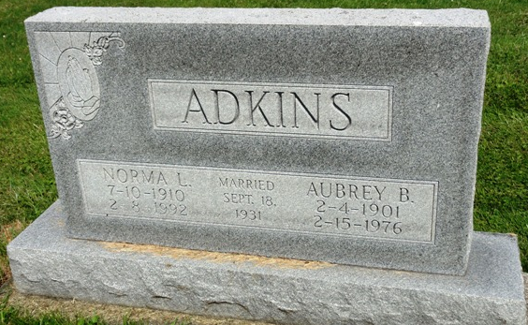
Photo by HoosierGirl88

Indiana, U.S., Death Certificates, 1899-2017
Name Norma Lucille Adkins
[Norma Lucille Morris]
Gender Female
Race White
Marital Status Widowed
Age 81
Birth Date 10 Jul 1910
Birth Place Muhlenberg County, Kentucky
Death Date 8 Feb 1992
Death Place Ossian, Wells, Indiana, USA
Death Registration Date 1992
Father Sam Morris
Mother Carolyn Richey
Informant Carolyn Donaghy, daughter
Burial 2/12/1992 Oak Lawn Cemetery

