Aubrey B. Adkins
February 4, 1901 – February 15, 1976

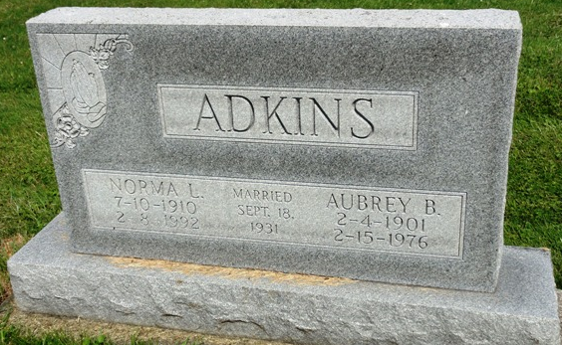
Photo by HoosierGirl88

Indiana, U.S., Death Certificates, 1899-2017
Name Audrey B Adkins
Gender Male
Race White
Marital Status Married
Age 75
Birth Date 4 Feb Abt 1901
Birth Place Kentucky
Death Date 15 Feb 1976
Death Place Fort Wayne, Allen, Indiana, USA
Death Registration Date 1976
Father Elmer Adkins
Mother Mattie Merrill
Spouse Norma Adkins, informant
Burial Oak Lawn 2-17-1976

