Victor Verron Adams
May 14, 1901 – December 20, 1974

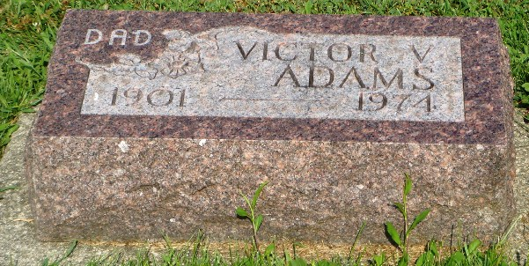
Photo by Kay Bradtmiller

Victor V. Adams, 73, former Ossian, Ind. Policeman, died unexpectedly Friday of complications in Harlingen, Texas Valley Baptist Hospital. He was born May 14, 1901, a son of the late William and Lillie VanGilder Adams in South Whitley, Ind.
Surviving are two sons, John and Don of Ossian; one brother, Quincey of Fort Wayne; four sisters, Mrs. Alice Clark of Los Angeles, Calif., Mrs. Bernice Twitchell, Mrs. Aletza Luebke and Miss Ruth Adams, all of Fort Wayne and seven grandchildren.
Funeral services will be Monday at the Elzey Funeral Home in Ossian. Burial will be at Oak Lawn Cemetery with Rev. James Woodworth officiating.

Wells County, Indiana Obituaries
1969 – 1975
(December 20, 1975)

