Ruth C. L. Adams
January 16, 1911 – April 1, 1993

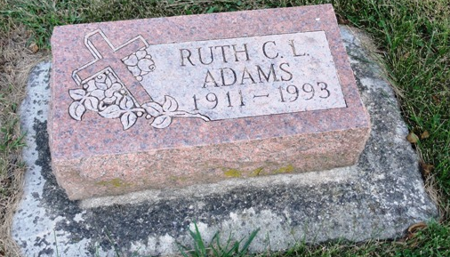
Photo by HoosierGirl88

Indiana, U.S., Death Certificates, 1899-2017
Name Ruth C Adams
Gender Female
Race White
Marital Status Unmarried (Single)
Age 82
Birth Date 16 Jan 1911
Birth Place Steuben County, Indiana
Death Date 1 Apr 1993
Death Place Fort Wayne, Allen, Indiana, USA
Death Registration Date 1993
Father William Dow Adams
Mother Lillie Viola Vangilder
Informant Donald D. Adams, nephew
Burial 4/3/1993 Oak Lawn Cemetery

