Quincy V. Adams
September 2, 1894 – January 14, 1989

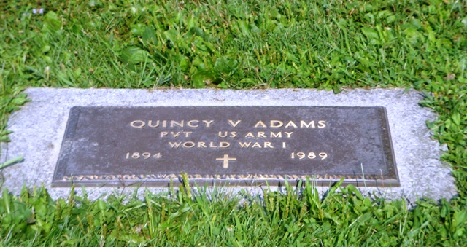
Photo by HoosierGirl88

Indiana, U.S., Death Certificates, 1899-2017
Name Quincy V Adams
Gender Male
Race White
Marital Status Divorced
Age 94
Birth Date 2 Sep 1894
Birth Place Steuben County, Indiana
Death Date 14 Jan 1989
Death Place Fort Wayne, Allen, Indiana, USA
Death Registration Date 1989
Father W D Adams
Mother Lillie Van Gilder
Informant Don Adams, nephew
Burial 1/17/1989 Oak Lawn Cem.

