Orion Edgar Adams
May 15, 1868 – January 30, 1943

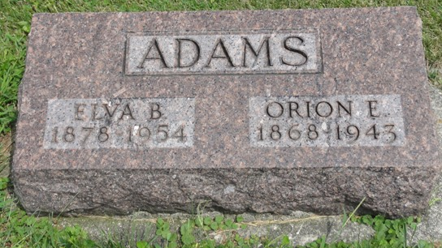
Photo by HoosierGirl88

Indiana, U.S., Death Certificates, 1899-2017
Name Orion Edgar Adams
Gender Male
Race White
Marital Status Married
Age 74y 8m 15d
Birth Date 15 May 1868
Birth Place Lagro, Indiana
Death Date 30 Jan 1943
Death Place Bluffton, Wells, Indiana, USA
Death Registration Date 1943
Father James Adams
Mother Louisana Becktel
Spouse Eva B Adams, informant
Burial Oak Lawn Cemetery 2/2/1943

