Lillie V. (Van Gilder) Adams
April 26, 1872 – January 4, 1954

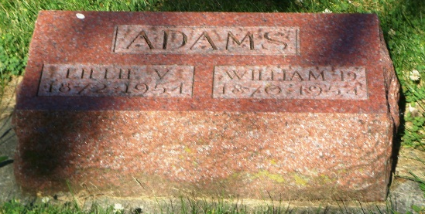
Photo by HoosierGirl88

Indiana, U.S., Death Certificates, 1899-2017
Name Lillie V Adoms
[Lillie V Gilder]
Gender Female
Race White
Marital Status Married
Age 81
Birth Date 26 Apr 1872
Birth Place Kansas
Death Date 4 Jan 1954
Death Place Ossian, Wells, Indiana, USA
Death Registration Date 1954
Father Leander Van Gilder
Mother Ella Weicker
Informant Mrs. Clar? Sh?? (very faded)
Burial 1/7/1954 Oak Lawn, Ossian, IN

