Howard E. Adams
February 19, 1929 – May 29, 2024

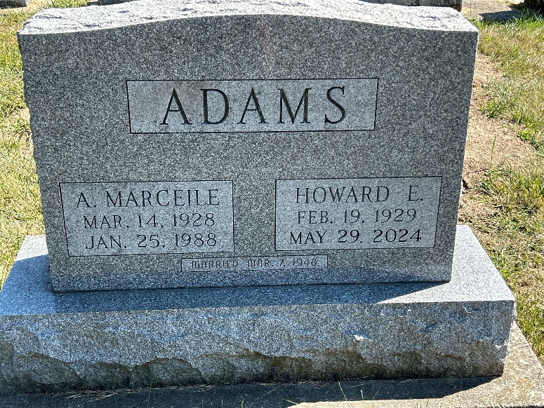
Photo by Barbara Baker Anderson

Howard E. "Red" Adams, 95, passed away Wednesday evening, May 29, 2024, at Markle Health and Rehabilitation in Markle, IN.
Howard was born in Bluffton, IN on Feb. 19, 1929, to John and Ruby (Shannon) Adams. He married Almeda Marceile (Elzey) in Bluffton on Mar. 7, 1948. Almeda preceded him in death on Jan. 25, 1988.
A 1948 graduate of Bluffton High School, Howard worked at Franklin Electric in Bluffton for 40 years, retiring in 1987, after retirement he worked at Miller & Sons Tool and Die in Warsaw part time until 2007. He was a former member of the Bluffton Elk's Lodge #796. Howard loved to water ski, sailing on their sailboat, he played several musical instruments, and enjoyed dancing and singing. He loved music, being a karaoke entertainer, and he was selfless in nature, most of all, "He lived a fun filled adventurous life".
Survivors include two daughters; Becky (Kim) Hartman of Leesburg, IN, and Pam (Ron) Lenwell of Markle, one son; Gary (Mary Lou) Adams of Leesburg, IN, 8 grandchildren, 15 grt. grandchildren and 7 grt. grt. grandchildren, one sister; Elanda Sue (Dave) Poff of Bluffton and one brother; Robert (Voneta) Adams of Muncie.
In addition to his parents and wife, Howard was preceded in death by three sisters; Betty Johns, Ruth Ann Hollingsworth and Mary Jo Satterfield and two brothers; Richard and Billy Adams.
Visitation will be held on Monday, June 3, 2024, from 11:00 AM until 2:00 PM at Goodwin – Cale & Harnish Memorial Chapel in Bluffton, followed immediately by a funeral service at 2:00 PM. Burial will follow at Oak Lawn Cemetery in Ossian. Tony Garton will officiate.
Memorials can be made to the Donor's Choice.

Goodwin Harnish Funeral Home, Wells County, Indiana

