Herman W. Adams
September 11, 1907 – March 15, 1961

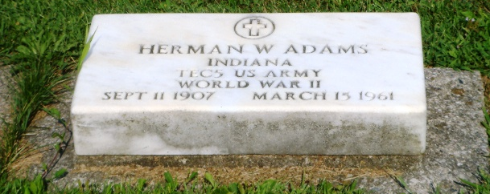
Photo by HoosierGirl88

Herman W Adams
in the U.S., Headstone Applications for Military Veterans, 1861-1985
Name Herman W Adams
Birth Date 11 Sep 1907
Service Number 15 085 789
Service Branch US Army
Unit Hq Co. 610th T.d.bn
Enlistment Date 15 Jan 1942
Discharge Date 7 Jan 1945
Death Date 15 Mar 1961
Cemetery Oaklawn Cemetery
Cemetery Location Ossian, Indiana, USA

