Elva B. (Stout) Adams
February 17, 1878 – April 8, 1954

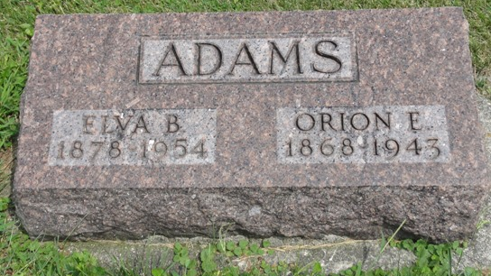
Photo by HoosierGirl88

Indiana, U.S., Death Certificates, 1899-2017
Name Elva Elle Adams
[Elva Belle Adams]
[Elva Elle Stout]
Gender Female
Race White
Marital Status Married
Age 76
Birth Date 17 Feb 1875
Birth Place Marion, Indiana
Death Date 8 Apr 1954
Death Place Bluffton, Wells, Indiana, USA
Death Registration Date 1954
Father Rufus Stout
Mother Ann Elizabeth Pegg
Burial 4/11/1954 Oak Lawn

