Donald Dean Adams Sr.
September 22, 1934 -

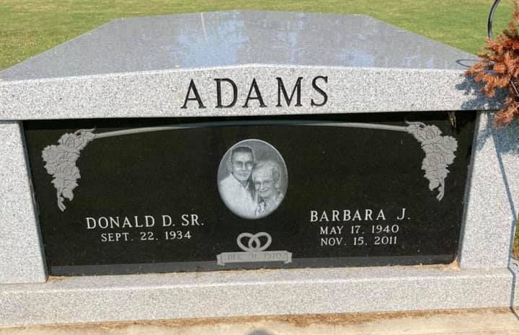
Photo by Scott Shoup

