Donald Dean Adams Jr.
December 23, 1953 – November 8, 1971

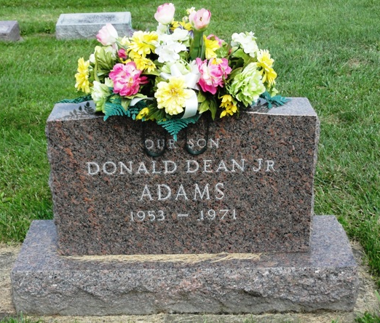
Photo by HoosierGirl88

Donald Dean Adams, 17, a Norwell High School senior, died Monday P.M. in Adams County Hospital.
Born December 23, 1953 in Allen County, he is survived by his father, Donald Dean Adams of Ossian, his mother, Mrs. Gene (Louella) Ault of Waynedale; his stepmother, Mrs. Barbara Woodward Adams; his stepfather, Gene Ault; one sister, Vicki of Waynedale; two stepbrothers, Kevin and Keith Woodward, at home in Ossian; a grandfather, Ossian Deputy Town Marshall, Victor Adams, and a grandmother, Mrs. Emma Dellinger of Angola.
Rites at First Methodist Church with burial in Oak Lawn Cemetery, Ossian.
Wells County, Indiana Obituaries
1969 – 1975
(December 20, 1974)
**
Norwell senior dies of accident injuries
Donald D. Adams, 17, of Ossian, Norwell high School senior, died at 1:30 p.m. Monday at the Lutheran Hospital, Fort Wayne, of injuries suffered in a two-car accident of Ind. 1, one mile north of Ossian.
His car collided head-on with another driven by John Robert White, 69, Easton Route 1, at 6 p.m. Sunday. White is a patient in the Clinic Hospital, Bluffton, and his wife, Florence, 63, was released after treatment.
Young Adams was believed enroute to Churubusco to visit a girlfriend, Jane Sheets, to whom he became engaged last week.
The victim a part-time employee of the Lewis Standard service station in Ossian, also attended a class at Central Vocational School in Fort Wayne.
Surviving are the father, and stepmother, Donald and Barbara Adams of Ossian; the mother and stepfather, Louella Ault and Gene Ault of Fort Wayne; a sister, Vicki; two stepbrothers, Kevin and Keith Woodward; the paternal grandfather, Victor Adams, Ossian night policeman; and a grandmother, Mrs. Emma Dellinger of Angola.
Services will be held at 2 p.m. Thursday at the First United Methodist Church in Ossian. Friends may call at the Elzey Funeral Home in Ossian after 7 p.m. today and at the church after 1 p.m. Thursday.
Decatur Daily Democrat; Adams County, Indiana
Tuesday, Nov. 9, 1971
Contributed by Janice Vasilovski

