Darlene L. (Richerson) Adams
May 6, 1948 – June 13, 2016

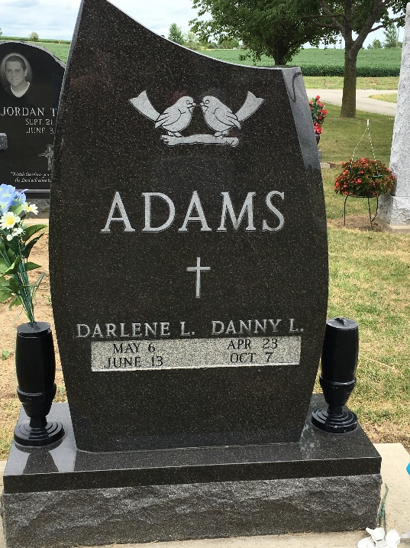
Photo by Barbara Baker Anderson

DARLENE L. ADAMS, 68, of Fort Wayne, went to be with God on Monday, June 13, 2016. She was a daughter of the late Roy and Frieda Richerson. She attended Elmhurst High School and "Streets of Waynedale". She was a member of American Legion Post 241 and AMVETS Post 33. She loved nature and animals.
Surviving family include her siblings, Jerry (Julie), Juno (Carole), Donna Richerson, and Betty Levy; several nieces and nephews; and her three dogs, Hoppie, Cheeka, and Jazzy. She was also preceded in passing by her husband, Dan Adams.
Graveside service is 1 p.m. Saturday, June 18, 2016, at Oak Lawn Cemetery, Ossian. Visitation is from 11 a.m. to 12:30 p.m. Saturday, June 18, 2016, at Elzey-Patterson-Rodak Home for Funerals, 6810 Old Trail Road, Fort Wayne. Memorials may be made to the Allen County Humane Society. Condolences may be left online at elzey-patterson-rodakfuneralhome.com

Unknown source

