Danny L. Adams
April 23, 1939 – October 7, 2013

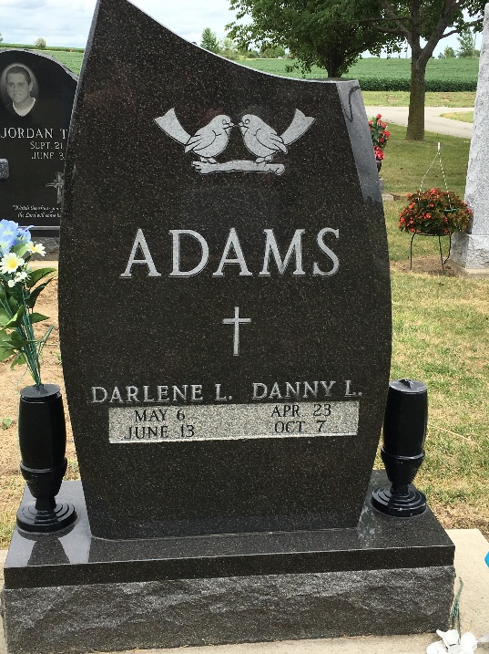
Photo by Barbara Baker Anderson

Danny L. Adams, of Fort Wayne, passed away Monday, October 7, 2013 at Lutheran Hospital. He was born in Mercer County, Ohio. He retired as an ironworker from the Iron Worker’s Local #147. He enjoyed NASCAR and Sprint Car Racing, was an avid chess player and loved animals.
Surviving are his wife, Darlene Adams of Fort Wayne; two grandchildren; one great granddaughter; one great grandson; brother, Darrell (Karol) Adams of Fort Wayne; several nieces, nephews, aunts, and uncles.
A graveside service will be held on Friday, October 11, 2013 at Oak Lawn Cemetery, Ossian at 2:30 pm with visitation prior at Elzey-Patterson-Rodak Home For Funerals, 6810 Old Trail Road, Fort Wayne, IN 46809 from 1:00 to 2:00 pm.
Memorials may be made to the Allen County Humane Shelter.

Elzey-Patterson-Rodak Home For Funerals, Allen County, Indiana

