Barbara J. (Schuller) Adams
May 17, 1940 – November 15, 2011

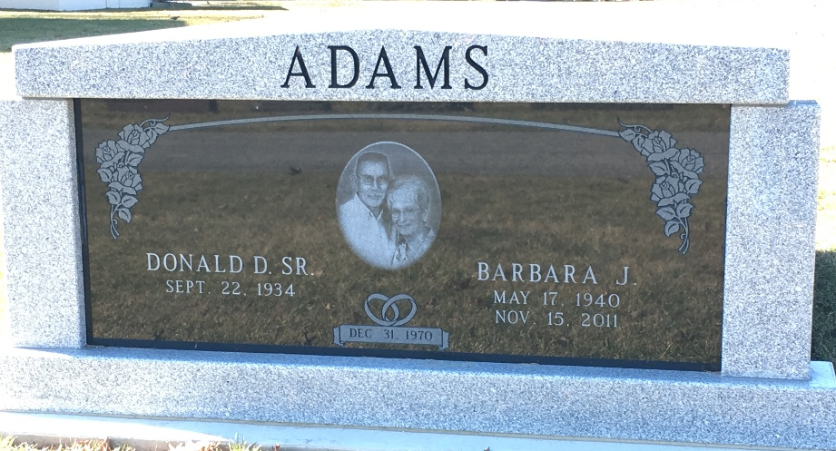
Photo by Barbara Baker Anderson

Barbara (Woodward) Adams, 71, of Ossian passed away Tuesday, Nov. 15, 2011. She was the daughter of Arthur Schuller and Flora Schluesemeier Schuller. She married Donald Adams Dec. 31, 1970.
She owned and operated Barb's Beauty Shop in Ossian for 38 years. She was a faithful member of Ossian United Methodist Church. She enjoyed volunteering at the Fort Wayne airport and at the Christian Care Retirement Community and was always ready to help others. Her family and friends were her greatest joy.
She is survived by her husband, Donald; two sons, Kevin (Linda) Woodward of Markle and Keith (Julie) Woodward of Edina, Minn.; and four grandchildren, Scott Woodward, Brock Woodward, Haley Woodward, and Graham Woodward.
She was preceded in death by her parents; her brother, Robert "Bob" Schuller; and her stepson, Dean Adams. She will be sadly missed by all who knew her and loved her; with our loss, God received a very special angel.
A funeral service will be held at 10 a.m. Monday, Nov. 21, 2011, at the Ossian United Methodist Church. Visitation will be from 2 to 7 p.m. Saturday, Nov. 19, 2011, and from 1 to 4 p.m. on Sunday, Nov. 20, 2011, at the Elzey-Patterson-Rodak Funeral Home, 120 W. Mill St., Ossian. Burial will be at the Greenlawn Memorial Park in Fort Wayne.
In lieu of flowers, the family suggests donations to the Barbara Adams Memorial at the Ossian United Methodist Church or at the Chanticleer Athletic Foundation.
Bluffton News Banner, Wells County, Indiana
November 17, 2011

